**Task 3: Extend the CI pipeline to deploy the application to Azure App Service or AKS, with approval gates for production.**

**Expected Outcome**: cd-pipeline.yml, deployment logs, screenshots of approvals in Azure DevOps.

* **cd-pipeline.yml:**

- stage: Deploy

displayName: 'Deploy to Azure App Service'

jobs:

- deployment: DeployApp

environment: 'Production'

strategy:

runOnce:

deploy:

steps:

- task: AzureWebApp@1

inputs:

azureSubscription: 'Myapp-ServiceConnection'

appName: 'my-demo-node-app'

package: '$(Pipeline.Workspace)/drop'

displayName: 'Deploy to Azure App Service'

* **deployment logs:**



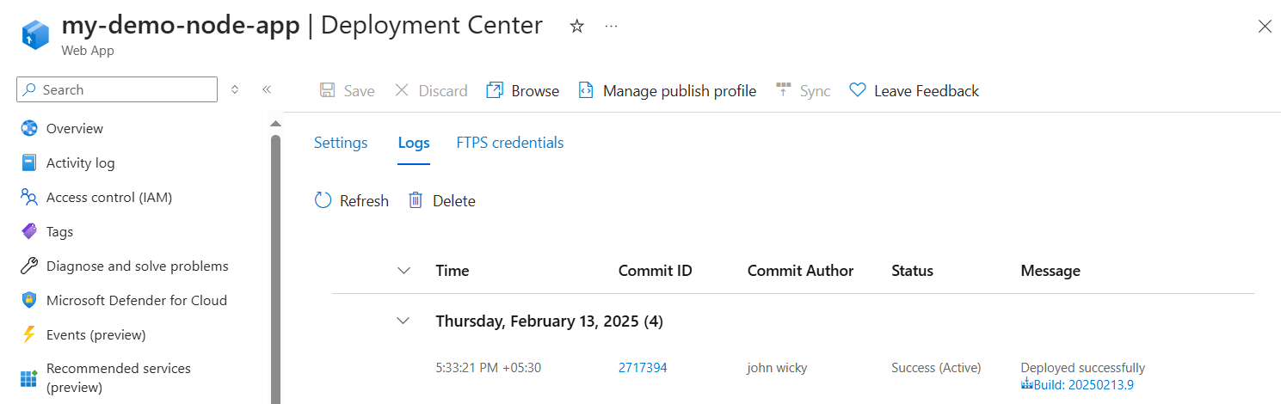

* **screenshots of approvals in Azure DevOps**

